create a HashSet class by add 10 numbers by using for loop and extra add some more objects and print the all the values.

create a LinkedHashSet class by add 10 numbers by using for loop and extra add some more objects and print the all the values.

By using Iterator class iterate the HashSet class Elements.

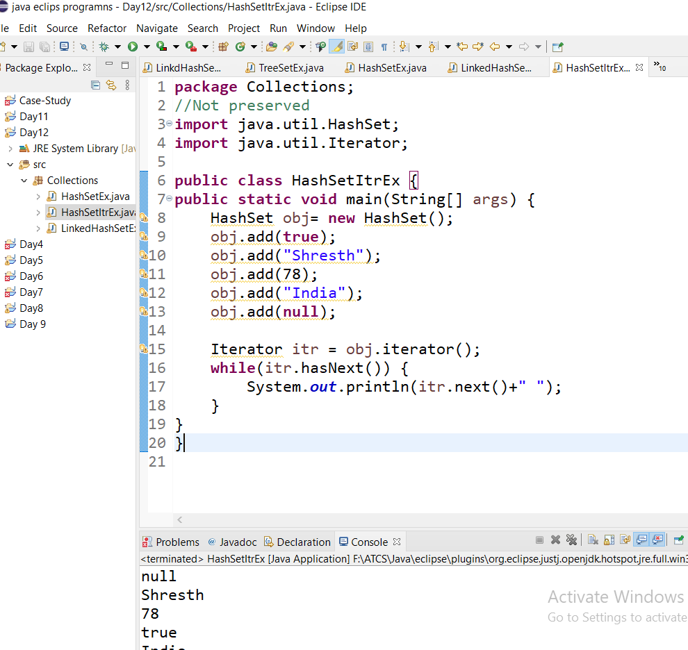

By using Iterator class iterate the LinkedHashSet Elements.

